Monday

SESSION 1 | SESSION 2
Functional literacy and numeracy  Learning outcomes  - ASDAN accreditation | Sporting activities  Learning outcomes  - ASDAN accreditation
Objective:  Match objects to symbols letters or words.  Engage in activities relating to counting in whole numbers  Numeracy  - Go into your kitchen and get the cutlery tray out – how many knives, spoons etc are there? Can you try writing the number on a piece of paper?  - Can you put the cutlery back carefully making sure all the knives are together and all the spoons etc?  - Can you set the table for lunch or tea so that each person has a knife, fork and spoon each? How many people are going to need cutlery?  - After lunch help dry up and practice putting the cutlery away again!  Literacy  - Do you know what these shops sell by looking at their signs? Can you recognise them? Match the symbol to the shop sign (see resources).  - Can you listen carefully to these questions and answer them appropriately?  - I want to buy some eggs – which shop could I go to?  - I need my hair cutting – where should I go?  - My car is broken where should I go to get it fixed?  Try and think of some more and ask your parent or carer if they know the answers. | Objective:  Take part in activities that contribute to keeping themselves healthy  Take part in different sporting activities  Try these fun workout activities – I think lots of you will know the songs in the main workout – have fun!  Warm up  https://www.youtube.com/watch?v=D5mGqvLplJQ  Workout  https://www.youtube.com/watch?v=yQ4fTl4wbko  Cooldown  https://www.youtube.com/watch?v=ngjXUUf4Nzs

Tuesday

SESSION 1 | SESSION 2
Preparing food and drinks  Learning outcomes  - ASDAN accreditation  Take part in preparing a variety of snacks  Follow basic safety rules when preparing snacks. | Forest School  Learning outcomes  - To develop a sense of well being and a connection with nature and the outdoors.
Objective:  Can you make a fruit salad?  - What fruit do you like? Can you chop an apple, peel and chop a banana, peel and separate the pieces of an orange or satsuma?  - What do you need to be careful with when chopping things? Why do you have to be careful?  - Can you make yourself a drink of juice? Be careful not to pour too much cordial in! | Objective:  Can you make something fun with a stick.  Can you find some really fabulous interesting sticks in your garden or on a walk?  What could your stick become? A magic wand? A stick person? A plane?  Can you make your stick into one of these things? See the sheet in resources for ideas but please try invent your own – it can be anything you want it to be.

Wednesday
SESSION 1 | SESSION 2
Learning for life (Learning about the wider world  Learning outcomes  Explore the wider world and our place within it | Creative activities  Learning outcomes:  - Q Arts Award  - ASDAN accreditation  Take part in different new creative activities
Objective:  To learn some new things about the USA.  This week we are thinking about the USA!  Look at the powerpoint slideshow and talk about the different aspects.  - Make a flag  - Can you help make a burger for lunch or tea?  - Can you make a toasted bagel and cream cheese for snack?  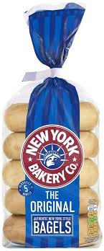  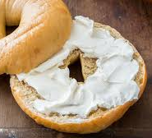  What else can you find out about America? | Objective:  To upcycle an old picture frame.  - Have you got an old picture frame you want to make look a bit more exciting?  - Find some magazines, wrapping paper, tissue paper and tear into small pieces about 2cm size.  - Add a little bit of water to some pva glue (use can use a glue stick but pva glue is better).  - Cover the whole frame in your chosen material, making sure you coat the top of the paper too and then leave it to dry.  Ta da – here’s mine! I used old newspapers!  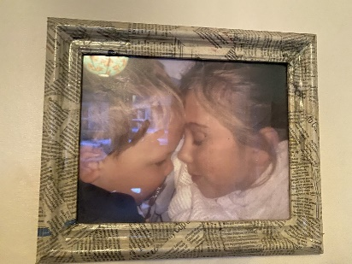

Thursday
SESSION 1 | SESSION 2
Developing independent living skills: being healthy  Learning outcomes:  ASDAN accreditation  Take part in activities that contribute to keeping themselves healthy. | Caring for the environment  Learning outcomes:  - John Muir award  - ASDAN accreditation  Take part in an activity to improve their local environment
Objective:  To learn about foods we can eat a little or a lot of.  Watch these videos and if you can then explore the other Eat Happy Project videos!  https://www.youtube.com/watch?v=mMHVEFWNLMc  https://www.youtube.com/watch?v=mMHVEFWNLMc  - Look at the food picture sheet and talk about which you like and which you don’t like.  - Think about which of these foods are healthy and we can eat lots of them and which ones aren’t healthy so we can only eat a little.  - Cut and stick the images into the two sections. Maybe you could try eat more of the things in the ‘eat lots of’ section or try something new that you’ve seen? | Objective:  To recognise how litter makes us feel in our environment.  Look at the two pictures in the resources section – what do you think about them? What is good and what is not good?  How do the two pictures make you feel?  Try this online game  https://www.bbc.co.uk/newsround/46365181  Watch this interesting video.  https://www.youtube.com/watch?v=a9Z-Xwrhmu0  Can you make a video about putting your litter in the bin to protect the environment?  Can you find any more videos about no littering campaigns?  Can you make a ‘Don’t drop litter’ poster?

Friday
SESSION 1 | SESSION 2
Developing independent living skills: keeping safe  Learning outcomes  - ASDAN accreditation  Recognise key factors in keeping themselves safe | Headspace and mindfulness  Learning outcomes  - ASDAN accreditation  Take part in activities that contribute to keeping themselves healthy.
Objective:  To learn about what do you need to do before you can leave the house?  What could happen if you walk out of the house without a coat on, leaving the door open and not locking it and wearing just your slippers on your feet?  - you make a short video of you leaving the house. You need to think about what the weather is like and what clothes and footwear you need to wear. Its no good wearing sandals if it is snowing! What about your front door – you will need to close it and lock it! Can you do this without being prompted?  - We would love to see your videos so don’t forget to email them to us!  Friday is Bakery Café Day too so sit with your family and have a nice cuppa and snack – maybe do some baking too? | Objective:  What can we do to help us feel good?  Looking after our mental wellbeing is so important – this means doing things that make us feel happy.  Suggestions for todays session are  - Paint your nails.  - Do a face mask – here are some recipes.  https://www.youtube.com/watch?v=9UoNhm5h2QU  - Listen to your favourite music – have a good sing song and do some dancing.  - Listen to some Forest Bathing meditation music.  https://www.youtube.com/watch?v=6iS4jxeakDY

