NORTH YORKSHIRE COUNTY COUNCIL

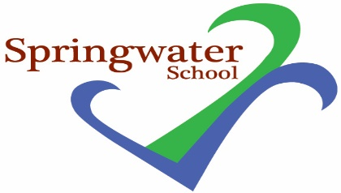

Head Teacher: Sarah Edwards

Springwater School Tel: 01423 883214
High Street School Mobile: 07957279719
Starbeck email: admin@springwater.n-yorks.sch.uk
Harrogate HG2 7LW School Fund Charity Number: 1096974

13th May, 2022
Dear Parents/Carers,

We have had the following information from NYCC:

Just to let you know that the 2022/23 Transport Policy and Link to ‘Apply and Pay’ is now available on the NYCC website – link below:

Transport to sixth form or college | North Yorkshire County Council

Please feel free to share with parents/carers of your Year 11 leavers/continuing Year 12/13s and Year 14 leavers – any queries should be directed to the Transport Team 01609 535077

Paper based application forms are available on request; forms can also be downloaded and printed from the Website.

Please note that applications should be made before 30 June as any received after this date may not be processed in time for September and in this situation parents may need to make own arrangements for transport for the first few weeks.

Where next provision is not yet confirmed, applications can be made with ‘the name of preferred provision’ indicated on the transport application and this can be notified and changed if anything different is confirmed later.

Where parents/carers do not know the course name/qualification to be studied they can tick ‘other’.
They must remember to tick that the learner has an EHCP.

PTO

Charge this year (for Post 16 transport) is £650 for the year (criteria for reductions for low income parents is listed on the website – reduced to £325 – or waived in particular Young Person circumstances). The cost is the same for all learners and attendance.

Applications can take around 4 weeks to process.

· Year 11s moving on to Year 12 need to apply
· Year 12 and 13s continuing need to re-apply
· Year 14s moving on to other education (e.g. PLC, Specialist college etc) need to apply for Post 19 transport – also via website – and they MUST HAVE a Transport Needs Assessment completed by their Social Worker – if they do not have a Social Worker they need to request an assessment URGENTLY – by contacting NYCC Customer Service 01609 780780 – transport will NOT be provided without this assessment. Please note that Post 19 Transport is not charged.

