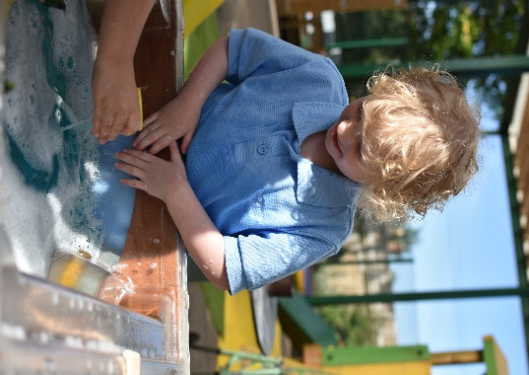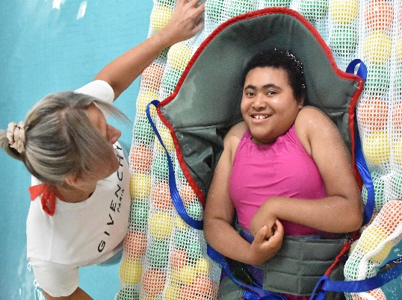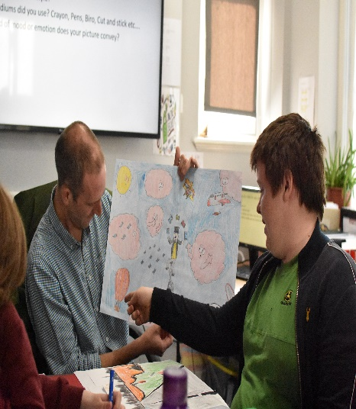

Springwater School is recruiting to support staff posts!
Following an increase in the pupil numbers at Springwater School there are several vacancies for teaching assistants and pupil support assistant roles.
Springwater is a North Yorkshire Special School, conveniently located between Knaresborough and Harrogate, in Starbeck. There are excellent transport routes from nearby towns and the school is a few minutes’ walk from Starbeck rail station which means that staff can travel from a little further afield such as York and Leeds.

As a North Yorkshire maintained school, staff enjoy access to:
- flexible working practices including parental leave and one annual personal leave day
- a market-leading pension scheme
- retail, travel and leisure discounts and salary sacrifice discount schemes through Everybody Benefits
- commitment to staff development and continuous learning
- progression and career-enhancement opportunities
- We are committed to promoting and protecting your mental health and wellbeing at work
We believe in the importance of inclusion, which is why we are always working towards being a more diverse, equitable, and inclusive employer.
- green travel loan scheme: an interest-free loan towards an annual season ticket to get you from home to work
- health and wellbeing: in addition to North Yorkshire County Council occupational health services, preferential rates on a private health scheme are available through payroll deductions
- holiday discounts: available via the Everybody Benefits scheme
- leisure facilities discounts: various discounts on facilities run by district councils and some private gyms
- eye care: staff who use a computer as a regular part of their job are entitled to a free eye test and potentially computer-specific glasses.
- professional qualifications: add value to your career by studying a professional qualification and benefit from staff reductions
- cycle discounts: save up to 32 % against the cost of a cycle
- green lease cars: take a private lease on a new low-emission car of your choice, fully maintained and insured by the provider. Staff will enter into a two or three year agreement for monthly gross salary deductions, which means a saving in tax, national insurance and pension. Eligibility criteria exist for this scheme
- home technology: take a private lease on the latest PCs, laptops, tablets and smart TVs. Staff will enter into a two-year agreement for monthly salary deductions, which means a saving in national insurance and pension where applicable. Eligibility criteria exist for this scheme

A bit about us!

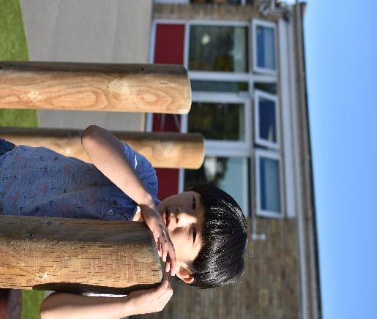
As a school we are committed to staff wellbeing and offer a friendly and supportive school setting. Support staff contracts are for term time only which may suit those with parental or carer responsibilities.
The school is committed to promoting and protecting your mental health and wellbeing at work by signing up to the DfE Wellbeing Charter.
We offer a comprehensive paid training package including Makaton signing, training for medical needs, Moving and Handling, pupil mental health and first aid. Our pupils have diverse needs and we cater for a wide age range (some of our pupils are a young as three years old, and we have a large sixth form which pupils leave at the age of nineteen) – meaning that many employees find their niche or specialism develops over time. Staff retention is extremely high, offering a stable and vibrant team. Support between colleagues is exceptionally good and is underpinned by a depth understanding of ‘cultural fit’ here and a commitment and focus on pupil needs.

We welcome applicants from a very wide range of backgrounds, including care, education, personal assistant work and completely unrelated fields of employment – all we ask is that you have a commitment to providing the very best for children and young people and advocating for them.
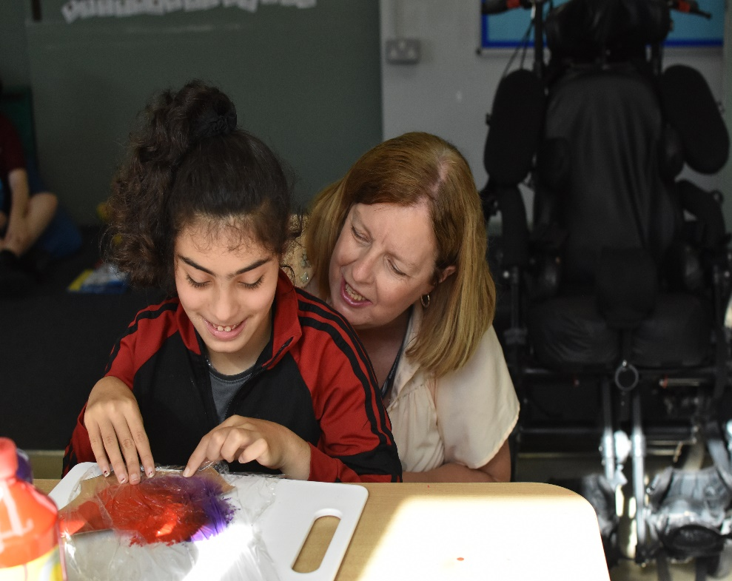

If you think this type of work would appeal, we have vacancies in support roles and for volunteers who would like to offer to support school on a regular basis. If you volunteer you can still access training free and develop your skills alongside experienced classroom staff. Many volunteers move on to be employed at the school, or into other related fields having gained experience here with us.

We will be offering open afternoons for anyone who may be interested in getting to know our school better and exploring the roles on offer.

These will take place on Wednesday 21^{st September} from 1.30 – 3.30 and on Tuesday 27th September 09.30 – 11.30 and will include an opportunity to speak to staff who work here, a tour, and a short talk by the HR manager.
If you would like to attend please email hnewton@springwater.n-yorks.sch.uk indicating which open event you would like to attend.

