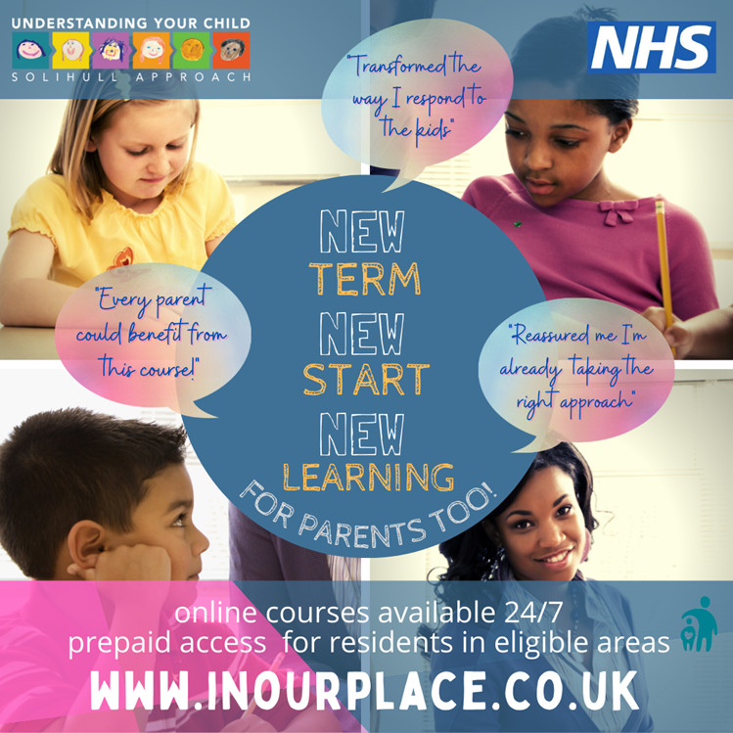
Hello,
Did you know North Yorkshire County Council have PRE-PAID for every parent and carer in North Yorkshire to access a range of courses for parents/carers (access now for life-long access)?
There are courses for parents, carers and grandparents about children from bump to 19+ years, from the Solihull Approach (NHS).

➢ www.inourplace.co.uk
➢ Access code: NYFAMILIES

• Understanding your pregnancy, birth, labour and your baby
• Understanding your baby
• Understanding your child (0-19+ yrs, main course)
• Understanding your child with additional needs (0-19+ yrs, main course)
• Understanding your child’s feelings (taster course)
• Understanding your child’s brain (short course)
• ‘Understanding your brain (for teenagers only!)’
• Understanding your child’s mental health and wellbeing (accompanies UYC and UYCAD)

➢ www.inourplace.co.uk
➢ Access code: NYFAMILIES

From us all with love

Rachel Yeadon
Senior Early Help Consultant: West
01609 798560 / 07816 165613

Early Help West 01609 (53)4842
EarlyHelpWest@northyorks.gov.uk

Children and Families Service: Early Help
Offering early help for children, young people and families

