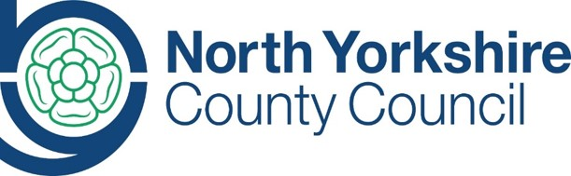
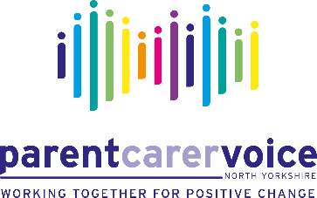

Does your child / young person have special educational needs and/or disabilities?
NYCC and PCV would like to work more closely with parents in local areas to ensure services are working for children / young people and their families.
Join us for our locality parent / carer virtual meetings where we would like to share information with you on the new SEND Hub structures and also have discussions with you about services for children and young people with SEND and how we hope to work with parent /carers moving forward.
Help us work together for positive change
Join us for our Zoom meetings
Area | Date | Time
Scarborough, Whitby & Ryedale | Tuesday 8th December | 10:00am – 11:00am
Hambleton & Richmondshire | Wednesday 9th December | 1:00pm – 2:00pm
Craven | Thursday 10th December | 10:00am – 11:00am
Harrogate | Thursday 10th December | 1:00pm – 2:00pm
Selby | Friday 11th December | 1:00pm – 2:00pm

To find out more or to book a place on one of the sessions please visit the events page on the Parent Carer Voice website at www.parentcarervoiceuk.org/events
If you would like more information or have any questions please contact us via email at info@parentcarervoiceuk.org

