[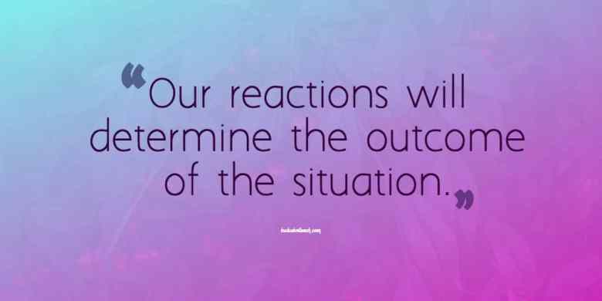](https://www.google.co.uk/url?sa=i&url=https%3A%2F%2Finclusiveteach.com%2F2016%2F05%2F22%2Fbehaviour-tips-for-controlling-your-emotions%2F&psig=AOvVaw0OUr59RBu19xeTQ06Fs266&ust=1608307620907000&source=images&cd=vfe&ved=0CAIQjRxqFwoTCLii6vyy1e0CFQAAAAAdAAAAABAK)

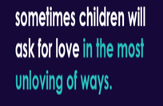

**Early Years**Terrible Two’s sound familiar? What about Terrific Two’s? Sometimes it is easy to forget that our children have only spent a few years in this world. They are constantly learning new language and social skills every day. It’s important to remember behaviour is a form of communication and this is very normal and part of your child’s developmental journey. Let’s put ourselves in their shoes, you have limited language and you haven’t learnt what emotions are and how to handle them yet. So what do you do when you can’t speak and you need help and attention. – tantrum! When children become overwhelmed their brains fill with a stress hormone, therefore they cannot focus and think. This is very normal. Have a look at some top tips for managing behaviour in the early years.

**Top Tips –** Why not have a go at turning a negative into a positive by changing your language.

* Get to their level and make eye contact – show them that you are there for them ready to listen and help when they have calmed down.
* Try to keep your sentences short and use simple language. Children understand and can process before they can talk.
* Name the emotions they are feeling e.g. I can see you are angry. This will help your child understand what emotions they are feeling and showing them you can express through language.
* Remember, it’s still important to have boundaries, choices and consequences so your child knows what is expected of them.

Check out this website for further advice <https://www.familylinks.org.uk/resources-for-parents>

**Welcome Message**

Hello and welcome to our latest Family Newsletter. This month’s focus is on challenging behaviour, something most parents experience at some point with their child. Many children go through phases of testing boundaries and parents often feel helpless, embarrassed and at times in despair about how to manage their children’s unwanted behaviours.

Challenging behaviours linked to emotions and feelings such as frustration, anger and disappointment, often trigger the unwanted behaviour you and your child may be struggling to cope with. You may feel unsure on the best approach to tackle this, so here’s our top tips, tried and tested strategies, and further signposting to more online information and techniques.

**Family Newsletter  
Edition 5: Challenging Behaviour**

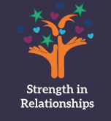



[](https://www.google.com/url?sa=i&url=https%3A%2F%2Fbeaconschoolsupport.co.uk%2Fnewsletters%2Fwhat-you-absolutely-need-to-know-about-behaviour-intervention-groups&psig=AOvVaw0TadwqvrlzSS-uE0S4tStK&ust=1608136240572000&source=images&cd=vfe&ved=0CAIQjRxqFwoTCKi_n8G00O0CFQAAAAAdAAAAABAD)

**Parents**  
Dealing with children’s challenging behaviour can be a struggle. We often ask ourselves *why they behave like this*. Our focus usually becomes firmly fixed on the child and their negative actions as we try to resolve things. However, it may well be worthwhile just taking a step back for moment to consider the examples we set our children when dealing with our own conflicts within our relationships. Parental conflict has a huge impact on children and their behaviour, to learn more visit these two websites and in particular watch the “see it differently” videos:

* Here to help: <https://www.worcestershire.gov.uk/reducingparentalconflict> ( see it differently videos)
* The impact of couple conflict on children: <http://tavistockrelationships.ac.uk/images/uploads/policy_use/policybriefings/Impact_of_Couple_Conflict_on_Children_FINAL.pdf>

**Other Useful Information**

* <https://www.nhs.uk/conditions/pregnancy-and-baby/dealing-with-difficult-behaviour/>
* <https://learning.nspcc.org.uk/media/1195/positive-parenting.pdf>
* <https://youngminds.org.uk/find-help/for-parents/parents-guide-to-support-a-z/parents-guide-to-support-challenging-behaviour-in-children/>
* <https://www.nhs.uk/conditions/social-care-and-support-guide/caring-for-children-and-young-people/how-to-deal-with-challenging-behaviour-in-children/>

**Primary and Secondary  
Behavioural Support**

Whether your child is at primary or secondary school, challenging behaviour can soon become problematic. For children of all ages, the boundaries of expected behaviours will change as they grow and negotiate family rules, respectful interactions and positive relationships can become a challenge.  
Daily life can become exhausting for everyone in the family when unwanted behaviour is present and as a parent it is important to remember it is possible to come through this – with support, your child can find healthier ways to express and manage their feelings, to ensure a more positive family life.

* <https://www.relate.org.uk/relationship-help/help-family-life-and-parenting/parenting-teenagers/behaviour/coping-disruptive-teenagers>
* <https://www.scope.org.uk/advice-and-support/managing-challenging-behaviour/>
* <https://youngminds.org.uk/find-help/for-parents/parents-guide-to-support-a-z/parents-guide-to-support-challenging-behaviour-in-children/>

**Emotional Support**Children experience a range of emotions and can express themselves in many different ways. It’s normal for school-aged children to show defiance at times and often lose control of their emotions, particularly while their social and emotional skills are developing.  It’s important that you and other caregivers offer reassurance during these times. Guiding your child and encouraging positive behaviours will help them learn appropriate ways to manage their emotions.

* <https://www.rch.org.au/kidsinfo/fact_sheets/Challenging_behaviour_school_aged_children/>
* <https://pathways.org/topics-of-development/social-emotional/>