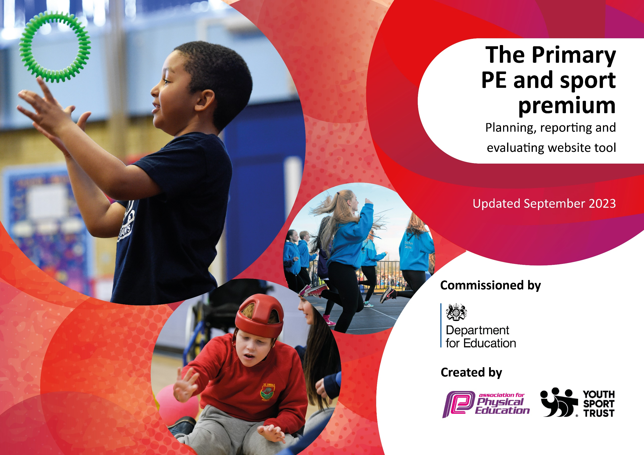

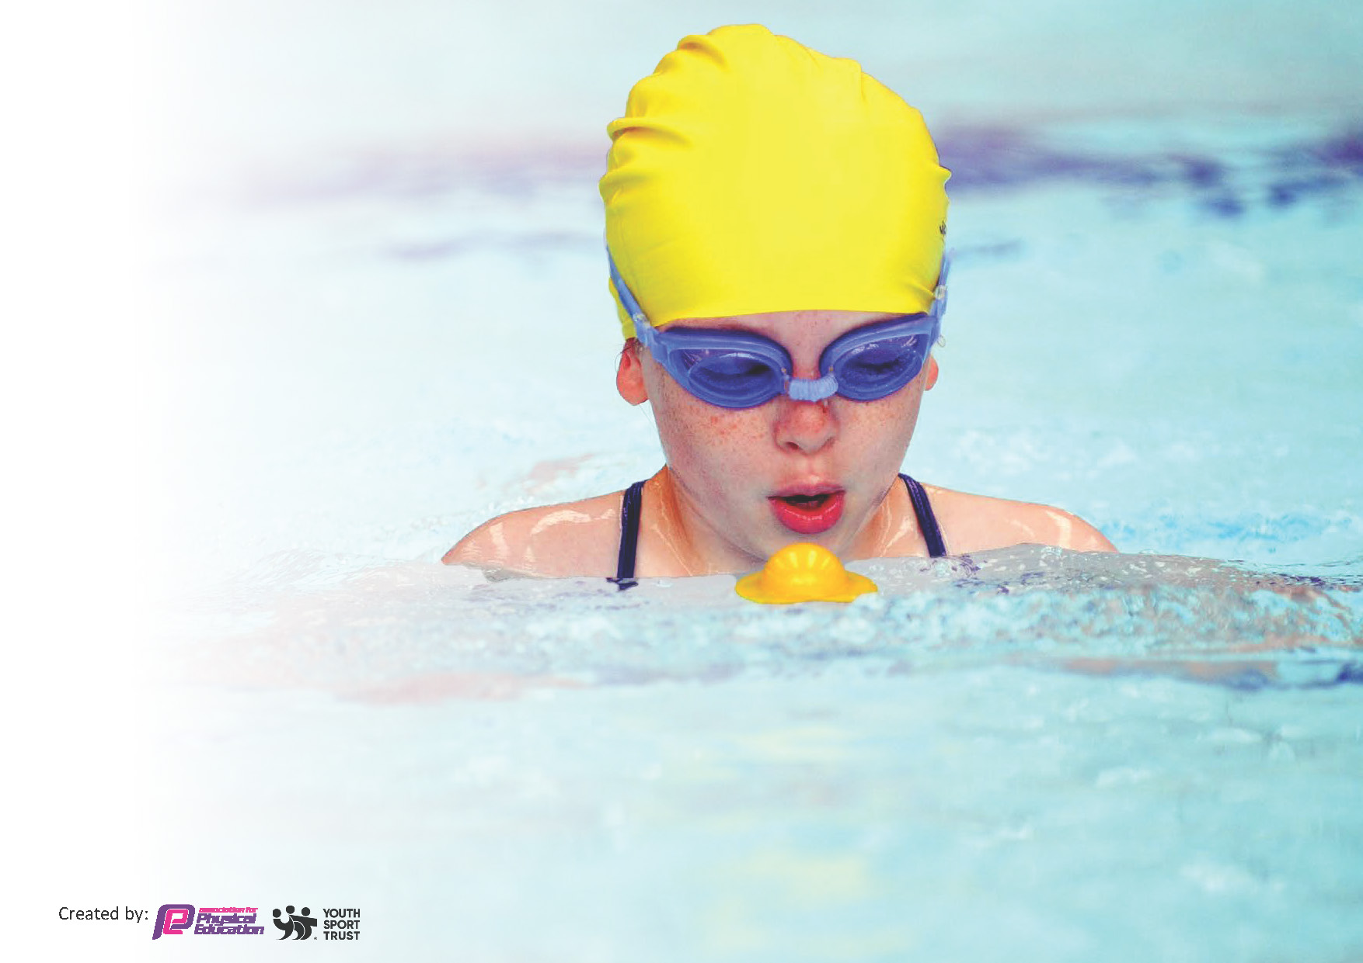
This template can be used for multiple purposes:
by:
- It enables schools to effectively plan their use of the Primary PE and sport premium
- It helps schools to meet the requirements (as set out in guidance) to publish information on their Primary PE and sport premium
- It will be an effective document to support Ofsted inspections enabling schools to evidence progress in Physical Education (PE) and evidence swimming attainment, which forms part of the PE National Curriculum. We would recommend schools consider
the Intent, Implementation and Impact of any spend, as examined within the Education Inspection Framework.

It is important that your grant is used effectively and based on school need.

Schools must use the funding to make additional and sustainable
improvements to the quality of the PE, School Sport and Physical Activity (PESSPA)
they offer. This means that you should use the Primary PE and sport premium to:

- Build capacity and capability within the school to ensure that improvements made now will benefit pupils joining the school in future years
- Develop or add to the PESSPA activities that your school already offers.

The Primary PE and sport premium should not be used to fund capital spend projects; the school’s core budget should fund these. Further detail on capital expenditure can be found in the updated Primary PE and sport premium guidance.

The Primary PE and sport premium guidance, outlines 5 key priorities that funding should be used towards. It is not

necessary that spending has to meet all the key priorities, you should select the priorities that you aim to use any funding towards.

Although completing this template is not a requirement for schools, schools are required to publish details of how they spend this funding. Schools must also outline what the impact this funding has had on pupils’ PE and sport participation and attainment and how any spending will be sustainable in the future. All funding must be spent by 31st July 2024.

The Department for Education has worked closely with the Association for Physical Education (afPE) and the Youth Sport Trust (YST) to develop this template and encourages schools to use it. This template is an effective way of meeting the reporting requirements of the Primary PE and sport premium.
Review of last year’s spend and key achievements (2022/2023)

We recommend you start by reflecting on the impact of current provision and reviewing your previous spend.

Activity/Action | Impact | Comments
The money was spent to improve participation in sport, to get more students into a range of different sports. To improve MATP resources and improve physical EHCP outcomes. | Students will show a greater confidence in trying new activities, a range of equipment, and staff will be able to create a more engaging MATP/ Physical development curriculum. | The students were able to take part in a wider range of activities, the lessons were more engaging.
Leeds United foundation. | To increase the quality of the formal Physical development curriculum. Allow students to develop their skills in a more sport specific environment. | Leeds United came into school to deliver a more formal curriculum across school. We were also given access to the club mascot, had a stadium tour, and some tickets to a game. This really increased the level engagement in the classes.
NYISSP | Students to have access to a range of offsite competitive fixtures in a range sports. | Students were able to access a range of offsite competitive situations. This included swimming, boccia sports hall athletics to name a few. This really builds confidence in our students and increases the overall wellbeing when they are presented with something for taking part or winning. It promotes communication and participation between schools with students of similar needs or abilities.

Key priorities and Planning
This planning template will allow schools to accurately plan their spending.

Action – what are you planning to do | Who does this action impact? | Key indicator to meet | Impacts and how sustainability will be achieved? | Cost linked to the action
To improve the Primary playground | To improve the facilities out on the primary playground. This will improve the continuous provision, and encourage students to engage in more physical activities, and consequently improve outcomes.  Students being more active too. | Key indicator 2 -The engagement of all pupils in regular physical activity – the Chief Medical Officer guidelines recommend that all children and young people aged 5 to 18 engage in at least 60 minutes of physical activity per day, of which 30 minutes should be in school. | More pupils meeting their daily physical activity goal, more pupils encouraged to take part in PE and Sport Activities. | £5865
LUF Summer SLA  LUF Aut/Spring SLA | This promotes a more formal curriculum for our older students, allowing them to experience a wider range of activities. This also promotes students to be more active throughout the day. | Key indicator 4: Broader experience of a range of sports and activities offered to all pupils. | More pupils meeting their daily physical activity goal, more pupils encouraged to take part in PE and Sport Activities, better concentration levels. | £3185  £1760
Resources | To promote and improve our MATP curriculum, this allows students more opportunity to work towards their EHCP outcomes. | Key indicator 2 -The engagement of all pupils in regular physical activity – the Chief Medical Officer guidelines recommend that all children and young people aged 5 to 18 engage in at least 60 minutes of physical activity per day, of which 30 minutes should be in school. | More opportunities to take part in a range of activities, to increase engagement. | £1000
SSP | Allows students to take part in competitive sport with people of similar age and ability across the county of N.Yorks. | Key indicator 5: increased participation in competitive sport.  Key indicator 2 -The engagement of all pupils in regular physical activity – the Chief Medical Officer guidelines recommend that all children and young people aged 5 to 18 engage in at least 60 minutes of physical activity per day, of which 30 minutes should be in school. | Confidence in taking part in competitive situations, access to new facilities and resources. | £550
Primary swimming | Allows students to become confident in the water, demonstrating a range of strokes, however that may look. | Key indicator 2 -The engagement of all pupils in regular physical activity – the Chief Medical Officer guidelines recommend that all children and young people aged 5 to 18 engage in at least 60 minutes of physical activity per day, of which 30 minutes should be in school.  Key indicator 4: Broader experience of a range of sports and activities offered to all pupils. | Being able to swim and be confident in the water, water safety for future residentials and trips. | £1540
Sensory room:  Laptop  software  equipment | To promote and improve our MATP curriculum, this allows students more opportunity to work towards their EHPD outcomes.  To improve the facilities out on the primary playground. This will improve the continuous provision, and encourage students to engage in more physical activities, and consequently improve outcomes.  Students being more active. | Key indicator 2 -The engagement of all pupils in regular physical activity – the Chief Medical Officer guidelines recommend that all children and young people aged 5 to 18 engage in at least 60 minutes of physical activity per day, of which 30 minutes should be in school.  Key indicator 4: Broader experience of a range of sports and activities offered to all pupils. | This will allow students to use the sensory room to better regulate their behaviours, as well as improve the sensory experience linked to the EHCP outcomes and link to the themes within the departments. | £660
Coaches | Access to competitive situations and | Key indicator 4: Broader experience of a range of sports and activities offered to all pupils.  Key indicator 5: increased participation in competitive sport. | This will allow students to access the NYISSP events across the county. | £150
Badgers playground | To improve the facilities out on the primary playground. This will improve the continuous provision, and encourage students to engage in more physical activities, and consequently improve outcomes.  Students being more active too. | Key indicator 2 -The engagement of all pupils in regular physical activity – the Chief Medical Officer guidelines recommend that all children and young people aged 5 to 18 engage in at least 60 minutes of physical activity per day, of which 30 minutes should be in school. | More pupils meeting their daily physical activity goal, more pupils encouraged to take part in PE and Sport Activities. | £2450

Key achievements 2023-2024
This template will be completed at the end of the academic year and will showcase the key achievements schools have made with their Primary PE and sport premium spending.

Activity/Action | Impact | Comments

Swimming Data
Meeting National Curriculum requirements for swimming and water safety.
Priority should always be given to ensuring that pupils can perform safe self-rescue even if they do not fully meet the first two requirements of the National Curriculum programme of study

Question | Stats: | Further context  Relative to local challenges
What percentage of your current Year 6 cohort can swim competently, confidently and proficiently over a distance of at least 25 metres? | 0% | We are a special needs school with students of all abilities. This current year 6 cohort do not have the physical capabilities to achieve the targets above, even with extra sessions.
What percentage of your current Year 6 cohort can use a range of strokes effectively [for example, front crawl, backstroke, and breaststroke]? | 0% | We are a special needs school with students of all abilities. This current year 6 cohort do not have the physical capabilities to achieve the targets above, even with extra sessions.

What percentage of your current Year 6 cohort are able to perform safe self-rescue in different water-based situations? | 0% | We are a special needs school with students of all abilities. This current year 6 cohort do not have the physical capabilities to achieve the targets above, even with extra sessions.
If your schools swimming data is below national expectation, you can choose to use the Primary PE and sport premium to provide additional top-up sessions for those pupils that did not meet National Curriculum  requirements after the completion of core lessons. Have you done this? | Yes | We are a special needs school with students of all abilities. This current year 6 cohort do not have the physical capabilities to achieve the targets above, even with extra sessions.
Have you provided CPD to improve the knowledge and confidence of staff to be able to teach swimming and water safety? | Yes | Previously we have trained staff in Halliwick.

Signed off by:

Head Teacher: | Sarah Edwards
Subject Leader or the individual responsible for the Primary PE and sport premium: | Jack Murphy-King -Teacher
Governor: | Shelagh Morris 11.03.24
Date: | 01/03/2024

