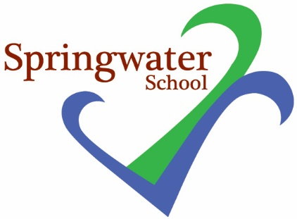

Class Teacher
Maternity Cover – full time
September 2022 to potentially 31st March 2023

Main-scale plus SEN

We are seeking to appoint an enthusiastic and committed teacher with appropriate qualifications and experience

Springwater School is a successful and popular all-age school catering for pupils with a wide range of challenges and needs.

Springwater School is committed to meeting the needs of our diverse community and aim to have a workforce reflecting this diversity. We are also committed to safeguarding and promoting the welfare of our pupils and young people. We have a robust Child Protection Policy and all staff will receive training relevant to their role at induction and throughout employment at the School. We expect all staff and volunteers to share this commitment. This post is subject to a satisfactory enhanced Disclosure and Barring Service criminal records check for work with children and satisfactory references.

If you think you possess the skills, talent and passion to join our team, we would like to hear from you. Applications from NQTs are welcomed. Further details and an application form are available from: hnewton@springwater.n-yorks.sch.uk

Closing date: 3 pm on Tuesday 5th July 2022
Interviews: Tuesday 12th July 2022

SPRINGWATER SCHOOL
HIGH STREET
STARBECK
HARROGATE HG2 7LW

