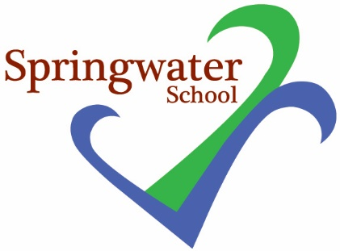
Springwater’s ‘SpringFestival’
Wednesday 18th July 1 – 2.45 pm

Dear Parents and friends of school

Next Wednesday we will be hosting our first SpringFestival. The Student Council wanted to create an event that brought school together to celebrate a wonderful school year, whilst also raising funds for the many projects and plans we have ongoing in school.

We are writing to ask you to join us on this special occasion. Please visit school and enjoy the many stalls and activities that the students across all departments are setting up for the event. Alongside this, we have Painting Pots visiting to make craft pieces, a music therapy tent, various musicians and our guest visitor is Nick Hancock from Stray FM, he will be joining us to introduce the acts to stage and meet the children and young people.

With this in mind, please send your young person with some funds to be able to take part in some of the activities and/or buy some of the products on sale at the event.

If you are able to donate raffle prizes, any support would be appreciated. We already have had a number of donations and the raffle is looking to be full of very exciting things, please see attached sheet.

Finally, if you do not wish for your young person to have their face painted, then please send the reply slip back below. Otherwise, we will assume that they can take part in this activity.

Thank you for your time and we really look forward to welcoming you to school on Wednesday18th July at 1 pm.

Kelly Tomlinson
Student Council and SMSC lead

To: Kelly Tomlinson

Name of child: _____________________________

I do not wish for my child to have their face painted.

Please only return if you do not wish your child to take part in this activity.

Signed:

