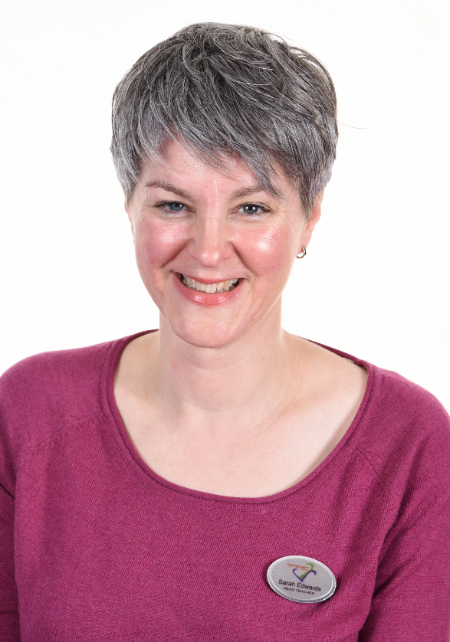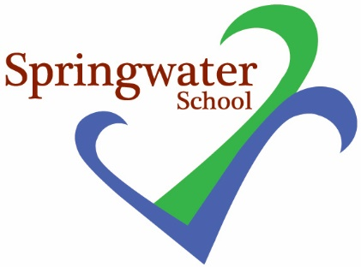

**Safeguarding is everyone’s responsibility.**

**Pass on your concerns without delay.**

**Copies of our Child Protection Policy can be found on SharePoint, the school website or in staffrooms.**

Andrew Sudron

Sarah Edwards

**If Andrew is not available, please speak to Sarah Edwards.**

**Safeguarding Team**

**The designated safeguarding lead in school is Andrew Sudron. If you are concerned about a child, please talk to him urgently.**