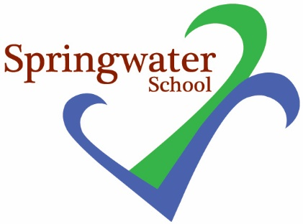

Do you know someone who is looking to break into education, and in particular a special school such as ours?

We are looking for all roles on an ad hoc supply (in the first instance) and voluntary basis – Pupil Support Assistants, and General Teaching Assistants and Teachers, If you are interested, please pass on your details to hnewton@springwater.n-yorks.sch.uk in the first instance.

We will check your qualifications, skills and experience and follow appropriate recruitment and vetting processes. All roles in school are subject to a DBS check.

We are also holding Recruitment Events –
Please attend school for either event:

Wednesday 8th November 2023
between 9.30 and 10 am
or
Tuesday 28th November 2023
between 09.30 and 10.30 am

Please email hnewton@springwater.n-yorks.sch.uk if you want to register to attend either of these.

We look forward to hearing from you.

