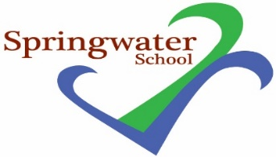

Monday 26th November 2018

Christmas market event

Dear Parents,
We will be holding a Christmas market here in school on Friday 14th December.
This will be a fun event with a Tombola and lots of various stalls, refreshments and a local choir.
This exciting event will run from 1.30pm to 2.30pm and we hope to see as many of you as possible there. Please feel free to send in some pocket money with your young person for them to spend.
If you have any donations for the tombola please could you send in to school by Wednesday 5th December.
Just a reminder also that we have no onsite parking, please use the streets around the school to park.

Many thanks
Peter Manning
Secondary HLTA
Makaton Regional Tutor

