Wednesday
SESSION 1 | SESSION 2
Welcome back  Learning outcomes:  - ASDAN accreditation  Recognise what they are good at and what they find difficult | Creative Activities  Learning outcomes:  - ASDAN accreditation  Take part in different new creative activities
Objective: Reflect on last year and set New Year’s resolutions  It has been a difficult year during 2020 and we look forward to the hopes and wishes of a New Year.  - Watch and listen:  https://www.youtube.com/watch?v=YAsV0zPnxg8&t=6s  Can you think of some things you would like to work towards as a New Year’s resolution? Is it a something new you would like to try or are you going to try and get better at something?  - Share your ideas with your family and friends.  Do they have any New Year’s resolutions they are trying to keep to this year?  - Complete the hopes and wishes for 2021 in your resources. You might like to add some photos of activities you are looking forward to doing again, people you would like to see or places you would like to travel to. | Objective: To create a piece of nature artwork  - Watch https://www.youtube.com/watch?v=jCulXPYPP4U  - Go into your garden and collect items such as leaves, flowers, sticks.  - What can you hear outside? What can you smell? What colours can you see?  - Create artwork using the items you have collected. Here are some ideas, or you can create your own.  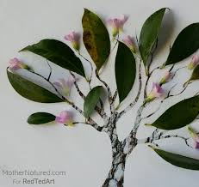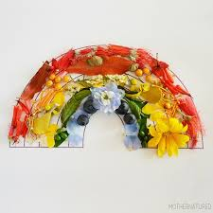  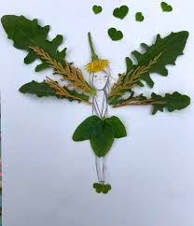

Thursday
SESSION 1 | SESSION 2
Developing independent living skills: Being healthy  Learning outcomes:  - ASDAN accreditation  Take part in activities that contribute to keeping themselves healthy. | Caring for the environment  Learning outcomes:  - John Muir Award  - ASDAN accreditation  Identify different harmful effects that people can have on the environment
Objective: To be active for 30 minutes  - Take part in one of the Youtube links for daily exercises and yoga, or walk around the garden.  https://www.youtube.com/results?sp=mAEB&search_query=cosmic+yoga+  (cosmic yoga)  https://www.youtube.com/watch?v=KZfQ6IE5POs (seated exercises)  - Take pictures of you completing your chosen activity.  - Did you enjoy it, how did it make you feel? | Objective: Create a poster  - Watch the YouTube video on how to care for the environment.  https://www.youtube.com/watch?v=X2YgM1Zw4_E  - Think about ways around the house you can help the environment and create a poster to remind others.  - Help out at home by remembering to turn off lights and taps when not in use, remember that certain rubbish items can be recycled, play an active role in this.

Friday
SESSION 1 | SESSION 2
Developing independent living skills: keeping safe  Learning outcomes  - ASDAN accreditation  Recognise key factors in keeping themselves safe  Be involved in keeping themselves healthy | Headspace and mindfulness  Learning outcomes  - ASDAN accreditation  Take part in activities that contribute to keeping themselves healthy.
Objective: To remind self about how to keep safe during the coronavirus pandemic  - Watch the video on how to keep safe during the coronavirus pandemic:  https://www.youtube.com/watch?v=x21by6BV0m0&t=115s  What things do we need to do to keep ourselves and others safe?  - Watch the video on handwashing. Practise washing your hands.  https://www.youtube.com/watch?v=aGJNspLRdrc | Objective: Practise the 5-finger breathing technique  Lockdown can be a difficult time and you may find yourself feeling different emotions and these emotions can sometimes become overwhelming.  - Watch the video showing the 5-finger breathing technique.  https://www.youtube.com/watch?v=DSgOW879jjA  - Practise this technique and start using this if your feelings start becoming too big and you feel overwhelmed. It is okay to feel these emotions at this challenging time.

