**Remote**

**Learning**

**Our Remote learning offer:**

A weekly plan of lessons and activities

A daily YouTube video correlating to these lessons

A weekly plan of lessons and activities taken from your child’s curriculum.

A daily YouTube video correlating to the lessons on your child’s weekly plan.

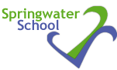

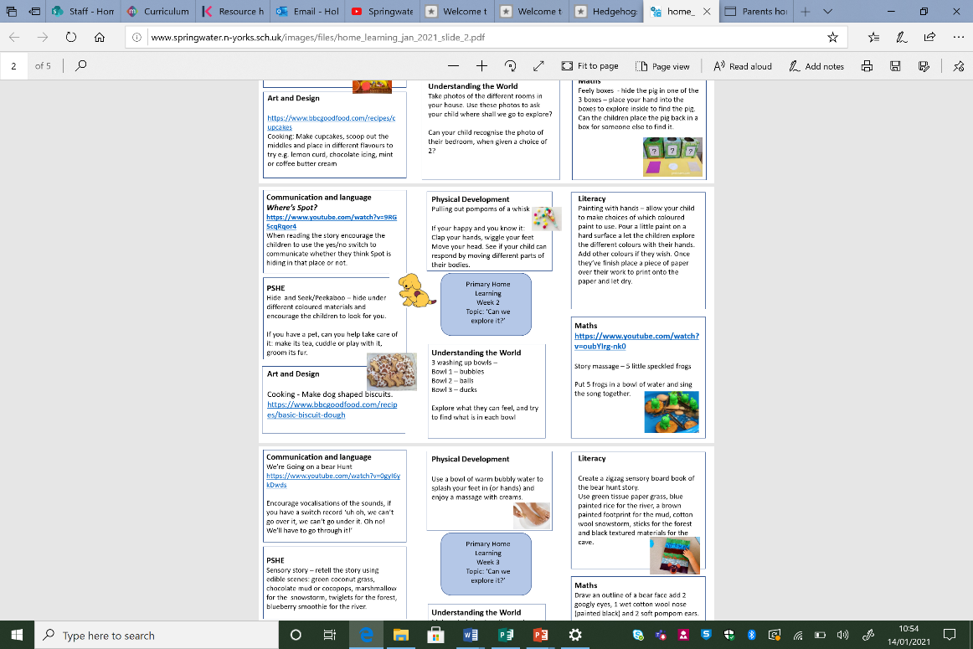****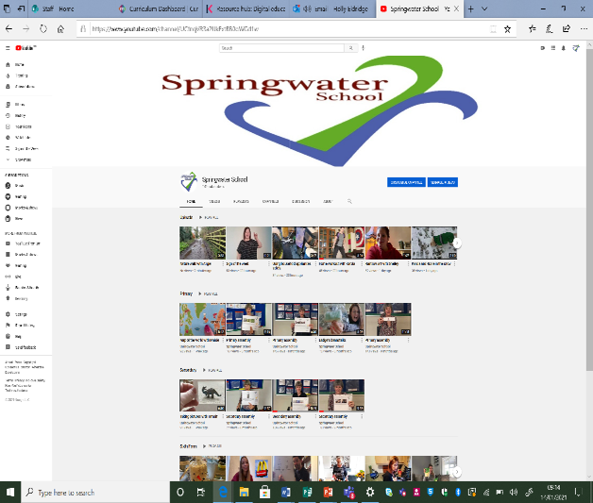

These tabs will take you to the home working guides

**Access**

**The weekly plan can be found on our website**

[**http://www.springwater.n-yorks.sch.uk/parents-carers/home-learning**](http://www.springwater.n-yorks.sch.uk/parents-carers/home-learning)

There is a link on the front page that will take you to their home learning plans, find the department and class your child is in and find the week by week plans.

**Weekly**

**Plans**

Every class has a weekly plan full of lessons and activities available on our website

Sixth form videos

**YouTube**

**Channel**

Multiple videos will be uploaded everyday linked to your child’s curriculum.

On our YouTube channel you will be able to easily navigate where to find videos under each department heading. Each video relates directly to the weekly learning lessons/activities and will be uploaded on the relevant week.

Primary videos

Secondary videos

**Access**

Our YouTube channel is <https://www.youtube.com/channel/UCtnqVR3a2UkExtBB0oWGd1w>