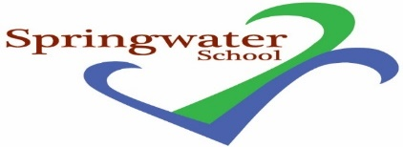

General Teaching Assistant (SEN)
posts available

Commencing Autumn Term 2022

5 day - 34 hours per week & 2/3 day part-time posts available
TTO Plus Training days

Monday, Wednesday and Friday 8.30 to 3.30 pm
Tuesday 8.30 to 4.30, Thursday 8.30 to 4 pm

Grade E

Springwater School is a successful and popular all-age special school catering for pupils with a wide range of challenges and needs.

The post holders will be part of dedicated staff teams, and we will provide you access to training support and professional development.

Springwater School is committed to meeting the needs of our diverse community and aim to have a workforce reflecting this diversity. We are also committed to safeguarding and promoting the welfare of our pupils and young people. We have a robust Child Protection Policy and all staff will receive training relevant to their role at induction and throughout employment at the School. We expect all staff and volunteers to share this commitment. These posts are subject to a satisfactory enhanced Disclosure and Barring Service criminal records check for work with children & adults and satisfactory references.

Further details including qualifications required - minimum NVQ Level 2 qualification in supporting teaching and learning or equivalent is essential for the GTA role, and application forms are available from:

Email: hnewton@springwater.n-yorks.sch.uk

Closing date: 9 am Friday 7th October 2022

Interviews: Thursday 13th October 2022

Springwater School
High Street
Starbeck
Harrogate
North Yorkshire
HG2 7LW

