November 2020
Dear school staff,

The Childhood Immunisation Team have set up a QR code system and a web link to gain feedback following our visit to your school to administer the flu vaccination. If you are receiving this email, we have already visited your school for the flu vaccinations or your visit will be upcoming in the next couple of weeks.

We have set this up in the hope that parents can scan the QR code or access the web link and assist their child/children to answer the short survey on their experience of their vaccination with our nurses. It is a very short survey and should only take a couple of minutes to complete. The questions are aimed at primary school and year 7 children and they should be able to answer them quite confidently themselves. Younger children may need more support from a parent/carer.

The survey could also be completed during an IT class in school if your children have access to computers or tablets. However, this is entirely up to you and what works best for your school.

We would be very grateful if you could share this QR code and web link on your school website and any social media pages you may have so parents can access either method. We hope to gain more of an understanding of the children’s experience of their flu vaccination in school and use this to improve our service for next year.

QR Code:
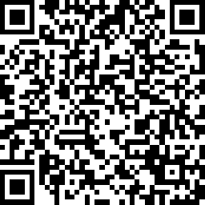

Web link:

https://www.surveymonkey.co.uk/r/J5298JJ

Both the QR code and the web link take you to the same survey. It is simply a choice of whatever is more accessible for the parent/carer and child or yourselves in school.

I will also include a copy of the QR code as a word document attachment to this email.

If you have any questions regarding this, please email us on hdft.childhood.immunisations@nhs.net

Yours sincerely,

Childhood Immunisation Team
North Yorkshire and City of York

