6
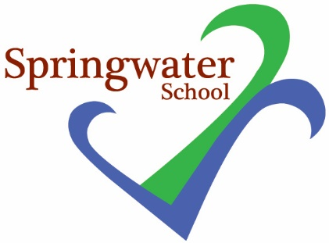

Tuesday 4th December 2018

Dear Parents and Guardians

On Friday 14th December we will be supporting Save the Children at Springwater School.

We would love everybody to wear their most festive jumpers to school on this special day.

Five Trees’ Café will be sharing some Christmassy treats – please join us there between 10.30 and 11.30 to support our fundraising efforts. There will also be Christmas themed activities for students during the day in their classes as we prepare for the final week of school before breaking for the holidays.

Further to this, Wednesday 19th December is our annual service at St Andrew’s Church in Starbeck; our gathering and sharing of student work takes place between 1.30 and 2.30pm.

Please complete the reply slip below if you are able to join us at our Christmas Service.

Thank you and best of Christmas wishes,

Kelly

Kelly Tomlinson
Teacher and RE/SMSC lead

Please return to school:

Student name: _______________________

I would like _________ seat (s) at the Christmas Service at St Andrew’s Church, on Wednesday 19th December.

Signed: ……………………………………………………………………..

