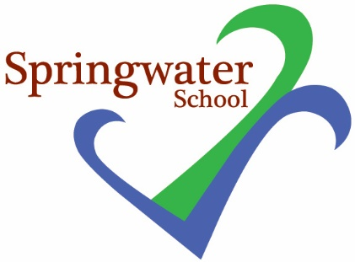

3rd December 2018

Dear Parents and carers,

I am writing to let you know that the Methodist Church car park where many of you park is now going to close to all vehicles at the end of the week (December 7th will be the last day for parking).

I am informed that this is all vehicles including parents from the neighbouring Starbeck Primary school, members of the public and staff.

The Church have been incredibly helpful and supportive to us over time, and I would like to take the opportunity to thank Rev Ann and her stewards for the parking they have provided in October and November.

We now have to ask that if you are accompanying your child to school or collecting them, that you no longer park in the Methodist Church Car Park.

Thank you.

Yours

Sarah Edwards
Head Teacher

