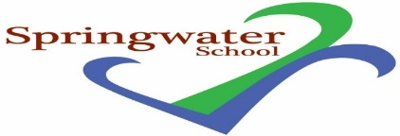
School based Assessment & Review Officer

32.5 hours per week – term time only

Monday, Wednesday and Friday 8.30 am to 3.30 pm
and Tuesday and Thursday 9 am to 4 pm

Permanent Contract from September 2022

Grade F

Springwater School is a successful and popular all-age school catering for pupils with a wide range of challenges and needs.

The post holder will be part of a dedicated school team, and we will provide you access to training support and professional development.

We are committed to meeting the needs of our diverse community and aim to have a workforce reflecting this diversity. We are also committed to safeguarding and promoting the welfare of children, young people and adults. We expect all staff and volunteers to share this commitment.

Springwater School is committed to meeting the needs of our diverse community and aim to have a workforce reflecting this diversity. We are also committed to safeguarding and promoting the welfare of our pupils and young people. We have a robust Child Protection Policy and all staff will receive training relevant to their role at induction and throughout employment at the School. We expect all staff and volunteers to share this commitment. This post is subject to a satisfactory enhanced Disclosure and Barring Service criminal records check for work with children and satisfactory references.

Further details including qualifications required, job description and application forms are available from:

Email: hnewton@springwater.n-yorks.sch.uk

Closing date: 9 am Tuesday 12th July 2022

Interviews: Friday 15th or Monday 18th July.

Springwater School
High Street
Starbeck
Harrogate
North Yorkshire
HG2 7LW

