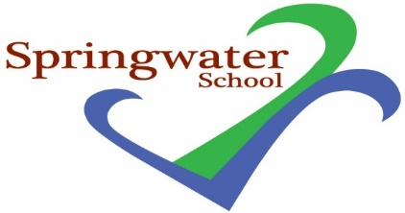

Administrative Assistant
Band 4
Monday, Tuesday & Wednesday
20.5 hours per week TTO (to include training days)
8.15 am to 3.45 pm Monday and Wednesday
8.45 am to 3.45 pm Tuesday

Springwater School is a successful and popular all-age school catering for pupils with a wide range of challenges and needs.

Springwater School are looking for a part time Administrative Assistant wo work in the school office on Monday, Tuesday and Wednesday, term time only. The post holder will be part of a small dedicated office team, and we will provide you access to training support and professional development. This role is permanent, term time only, plus one week of training days.

The successful applicant, may, on occasion, be required to work flexibly, covering for other members of the administration team in their absence or working additional hours if needed. The successful applicant will provide administration duties for the day-to-day management of the school office.

Previous office experience, strong IT capabilities, being flexible in approach, a strong work ethic, and having the ability to remain calm, will all be essential qualities in this varied role. Previous work in a school office or with school systems would be advantageous but is not essential.

Springwater School is committed to meeting the needs of our diverse community and aim to have a workforce reflecting this diversity. We are also committed to safeguarding and promoting the welfare of our pupils and young people. We have a robust Child Protection Policy and all staff will receive training relevant to their role at induction and throughout employment at the School. We expect all staff and volunteers to share this commitment. This post is subject to a satisfactory enhanced Disclosure and Barring Service criminal records check for work with children/adults and satisfactory references.

Further details including qualifications required and application forms are available via email to: hnewton@springwater.n-yorks.sch.uk

Closing date: 9am Monday 10th October 2022

Interviews: Friday 14th October 2022

Springwater School
High Street
Starbeck
Harrogate
North Yorkshire
HG2 7LW

